1. 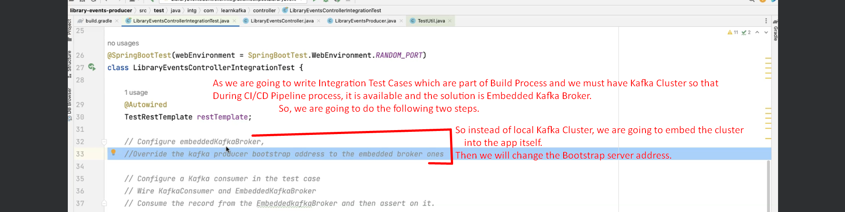
2. 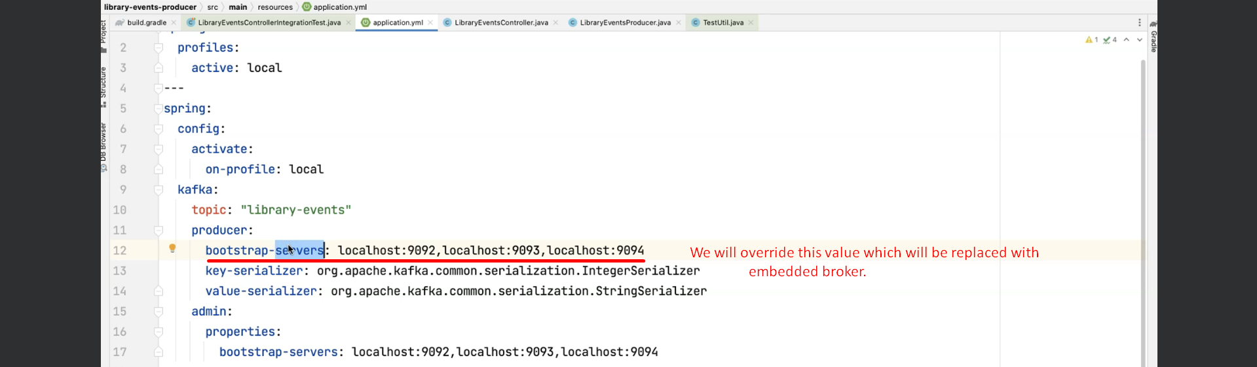
3. Let’s first configure Embedded Kafka Broker with topic name.
   1. **@EmbeddedKafka(topics = ”library-events”)**:
      1. This annotation will configure an embedded Kafka Broker.
      2. This is going to create topic “library-events” in the embedded Broker.
4. Next Step is to configure the bootstrap address for Embedded Kafka Broker.   
   Jatin forgot: @EmbeddedKafka will add some properties to Spring Context like   
   **spring.embedded.kakfa.brokers**   
   